|  |  |  |  |
| --- | --- | --- | --- |
| **Primary Media Contact:**  Advantech Co., Ltd.  Silvia Huang  Tel: +886-2-2792-7818, Ext. 7623  [Silvia.Huang@advantech.com.tw](mailto:Silvia.Huang@advantech.com.tw) |  |  | **2nd Media Contact:** |

**Advantech Launches a New Generation Fanless Panel PC: PPC-L158**

***August 4, 2011, Taipei* –**Advantech, the embedded platform and integration services provider, is happy to announce the PPC-L158 fanless panel PC, a new generation system powered by an Intel® Atom™ D525 Processor, dual-core 1.8 GHz. PPC-L158 delivers high performance computing suitable for machine automation and equipment manufacturing environments and is very cost-effective. PPC-L158’s green concept design reduces energy consumption while being environmentally friendly. The system is highly expandable and customizable to meet unique customer needs.

**High Performance Fanless System and Extremely Flexible**

In the past, fanless systems have sometimes been overlooked for applications that demand high CPU load over concerns of reliability. Now, leading the trend in fanless system development, the PPC-L158 represents a new generation of fanless panel PCs. It uses the Intel® Atom™ D525 Processor with a dual-core that gives it twice the performance of N270 processor Panel PCs. PPC-L158 can help customers execute more complex functions while still providing high reliability. The system is also built with a swappable pin head design, allowing a customer to choose different configurations. Choices include a PCI slot, PCIe slot, 2 USB ports, or a printer port. The flexible configuration of the PPC-L158 allows it to be matched to specific application requirements and a powerful processor ensures a stellar performance.

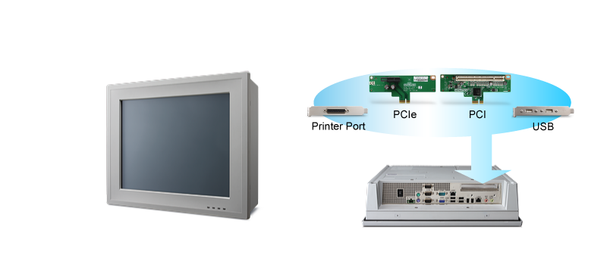

**Power Support and Anti-Corrosive Design for Demanding Environments**

PPC-L158 has the option to operate in either AC or DC power mode, which can be specified at the time of purchase. The touchscreen panel is built with an anti-corrosive and chemical resistant finish. PPC-L158 is at home in manufacturing lines, chemical production plants, and many other diverse factory environments.

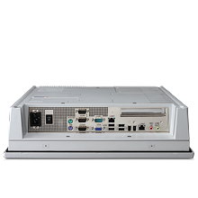 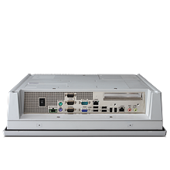

AC Mode

DC Mode

**Green and Cost-Effective Design**

One of the ways the PPC-L158 reduces power consumption is through the use of an LED backlight on its LCD panel. It’s also designed with a special power controller which is compliant with European ErP Lot 6 standard for energy-related products (DC Mode only). This means that PPC-L158 can be put in a low energy standby mode. The high-performing, highly-flexible and green PPC-L158 has another surprise too. It is built with careful consideration to cost, ensuring a great price-performance ratio which is difficult to beat.

**Additional Features at a Glance**

* 15" TFT XGA LCD with optional resistive touchscreen
* Embedded Intel® Atom™ Processor, dual-core D525 1.8 GHz
* System memory up to 2 x DDR3 800 MHz SODIMMs
* Supports one internal SATA 2.5" HDD
* Supports one Mini PCIe socket, dual Gigabit Ethernet
* Expansion kit for either PCI/PCIe
* Fanless and ultra-low power consumption
* One RS-232/422/485 (supporting Auto-flow control, BIOS-selectable)
* One RS-232/ GPIO (8-channel, TTL level by swapping pin header)

PPC-L158 offers high-flexibility, high-computing performance, and is extremely cost-effective. It is ideal for modern industrial applications, especially where economy is important. For more information about PPC-L158, or other industrial host systems, please contact a local sales office or visit our website: [www.advantech.com](http://www.advantech.com).

###

**About Advantech**

Founded in 1983, Advantech is a leader in providing trusted, innovative products, services, and solutions. Advantech offers comprehensive system integration, hardware, software, customer-centric design services, embedded systems, automation products, and global logistics support. We cooperate closely with our partners to help provide complete solutions for a wide array of applications across a diverse range of industries. Our mission is to enable an intelligent planet with Automation and Embedded Computing products and solutions that empower the development of smarter working and living. With Advantech, there is no limit to the applications and innovations our products make possible. (Corporate Website: [www.advantech.com](http://www.advantech.com/)).